Sorry for all the text, but it should be pretty brief. It’s basically 1.5 pages with a big screenshot.

# SETUP

The setup is slightly different from before, unfortunately, but it’s also much simpler, which should hopefully make working with it easier in the long term.

To add one of the music tracks to a scene, first configure an AudioSource as you would normally, with the music track as the “AudioClip”. Then attach a “CustomMusicLoopController” onto the GameObject with the AudioSource. It should look something like this:

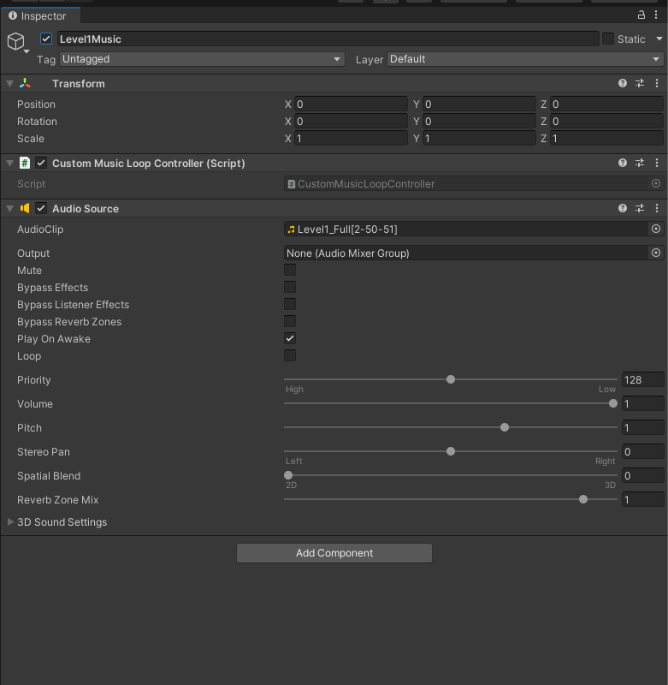

**The controller will then handle all of the initialization on Awake.** As an aside, you can use the “PlayOnAwake” flag on the AudioSource itself to have a track play automatically. Or, if you need to have it start from a script, disable “PlayOnAwake”, and then call “StartTrack()” on the CustomMusicLoopController.

Right now, the CustomMusicLoopController assumes that it only controls one AudioSource, so if you want to have multiple AudioSources on a single GameObject, you’ll have to make the “Initialize()” function public, and configure things manually (as in the old system).

# MAIN MENU

**The Main Menu music transition happens faster now**, but it’s still controlled from a script called “MainMenuMusicManager”, which has been slightly overhauled. You can also now call its “Initialize()” function with a specification to skip the prologue music.

Most importantly though, **you still need to call “StartMainMenuMusic()” to trigger the transition** from prologue to main menu. And in addition, **you will need to make sure “PlayOnAwake” is disabled for the prologue and main menu controllers.** If you want to leave this enabled, for whatever reason, you can modify the Initialize() code to start and stop the appropriate tracks accordingly.

# OTHER THINGS

The audio clips have weird names because, for ease of integration, I’m lazily **storing the loop information in the filename itself**. If it would be more logical to store the information somewhere else, or if there is some naming convention that requires the filenames be named some other way, this is all the information needed for the calculations:

* Level1
  + loopStartBar: 2
  + loopEndBar: 50
  + totalBarCount: 51
* Level2
  + loopStartBar: 2
  + loopEndBar: 36
  + totalBarCount: 37
* LevelSelect
  + loopStartBar: 12
  + loopEndBar: 18
  + totalBarCount: 20
* MainMenu
  + loopStartBar: 3
  + loopEndBar: 27
  + totalBarCount: 28
* Prologue
  + loopStartBar: 2
  + loopEndBar: 18
  + totalBarCount: 19

That’s all! Sorry that Level 3 music isn’t in yet, hopefully I’ll finish that by this weekend, but it seems as though that won’t be ready by the next build. And of course, let me know if you have any questions or if there are any issues.